**Cross Hedging Cryptocurrency**

Rohit Garg ([f2005636@gmail.com](mailto:f2005636@gmail.com))

A cryptocurrency or crypto currency is a digital asset designed to work as a medium of exchange that uses cryptography to secure its transactions

Cryptocurrencies are classified as a subset of digital currencies and are also classified as a subset of alternative currencies and virtual currencies.

The economics behind cryptocurrency

Cryptocurrency is a type of digital currency that uses cryptography for security and anti-counterfeiting measures. Public and private keys are often used to transfer cryptocurrency between individuals.

As a counter-culture movement that is often connected to cypherpunks, cryptocurrency is essentially a fiat currency. This means users must reach a consensus about cryptocurrency's value and use it as an exchange medium. However, because it is not tied to a particular country, its value is not controlled by a central bank. With bitcoin, the leading functioning example of cryptocurrency, value is determined by market supply and demand, meaning that it behaves much like precious metals, like silver and gold.

Cryptocurrency is designed to bring back a "decentralized currency of the people," taking centralized banks out of the equation. Because bitcoins must be cryptographically signed each time they are transferred, each bitcoin user has both public and individual private keys.

Possible abuse of crypto currencies

Cryptocurrency transactions are anonymous, untraceable and have created a niche for illegal transactions, like drug trafficking. Because the currency has no central repository, law enforcement and payment processors have no jurisdiction over bitcoin accounts. For cryptocurrency supporters, this anonymity is a primary strength of this technology, despite the potential for illegal abuse, as it enables a shift in power from institutions to individuals.

Types of Cryptocurrencies

Although there are technically over 1000 cryptocurrencies, only a handful are relevant.

Bitcoin: Bitcoin is an easy pick. It was the first major usable cryptocurrency, it has the highest market cap, its coins generally trade at the highest cost of all cryptocurrencies.

Ripple: Ripple tends to have a steady price due to its large supply. It has had staying power over time. It’s a popular and speedy alternative to Bitcoin that often is less volatile than other coins.

Ethereum: Is probably the third most important coin. It doesn’t have the longevity at the top like Litecoin, but it is built on a system that other coins are built on. Most ICOs (Initial Coin Offerings) use ethereum. It has a less intimidating cost that Bitcoin, and has the second highest market cap.

BitcoinCash: BitcoinCash is a spin-off of bitcoin, meant to have faster transactions, voted on and implemented by the Bitcoin community.

Litecoin: The Litecoin Network aims to process a block every 2.5 minutes, rather than Bitcoin's 10 minutes. The developers claim that this allows Litecoin to have faster transaction confirmation.

Tether: Tether is meant to reflect the price of the US dollar. There are some criticisms to consider. But if you want a stable coin for temporary use, Tether tends to be a good choice. It isn’t an investment, it is a place to park your value when you are in-between coins.

**Figure 1: How Cryptocurrency works**

**Data Summary**

Time series analysis is concerned with the analysis of data collected over time. Adjacent observations are typically dependent. Time series analysis hence deals with techniques for the analysis of this dependence.

**We create a zoo objects called btc from the daily closing prices of Bitcoin and ltc from the daily closing prices of Litecoin which are stored in the CSV files.** Each line on the sheet contains a date and a closing price separated by a comma. The first line contains the column headings (Date and Close). To get a first impression of the data, we plot the price chart:

**Figure 2: Closing prices of Bitcoin and Litecoin**

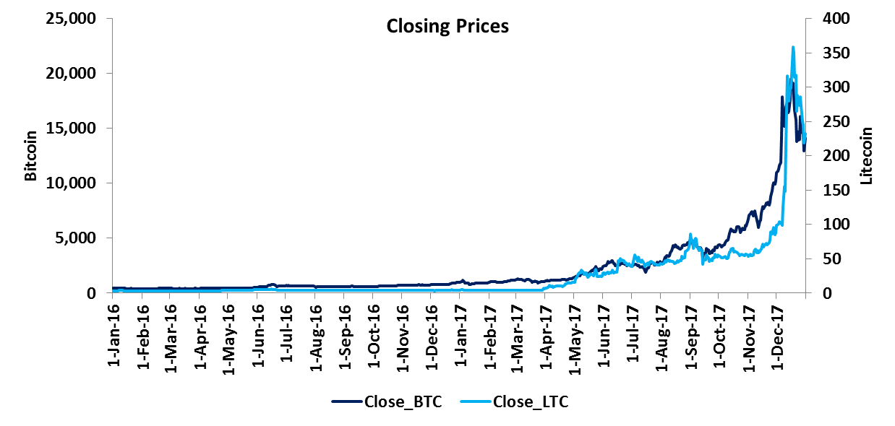

**Table 1: Date Range and Data Range**



When dealing with time series, one is normally more interested in returns instead of prices. This is because returns are usually stationary. So we will calculate continuously compounded returns:

**ret_btc = diff(log(btc)) * 100**

**Cross hedging Bitcoin**

Since the price of Bitcoin can be very volatile, most investors should hedge at least part of their exposure to Bitcoin price changes. In the absence of Bitcoin OTC instruments, investors can use related cryptocurrencies for hedging purposes. In this example Litecoin has been used to hedge.

**Cointegration: The idea behind cointegration is to find a linear combination between non-stationary time series that result in a stationary time series. It is hence possible to detect stable long-run relationships between non-stationary time series.**

Testing Bitcoin for stationarity: The null hypothesis of non-stationarity (Bitcoin time series contains a unit root) cannot be rejected at the 1% significance level

**Table 2: Testing Bitcoin for stationarity**



Testing Litecoin for stationarity: The null hypothesis of non-stationarity (Litecoin time series contains a unit root) cannot be rejected at the 1% significance level

**Table 3: Testing Litecoin for stationarity**



**Now we try to estimate the hedge ratio by using an existing long-run relationship between the levels of Bitcoin and Litecoin prices. We obtain a hedge ratio of 61.23.**

**Table 4: Estimating hedge ratio**



Testing error for stationarity: The null hypothesis of non-stationarity (error time series contains a unit root) is rejected at the 1% significance level

**Table 5: Testing error for stationarity**

